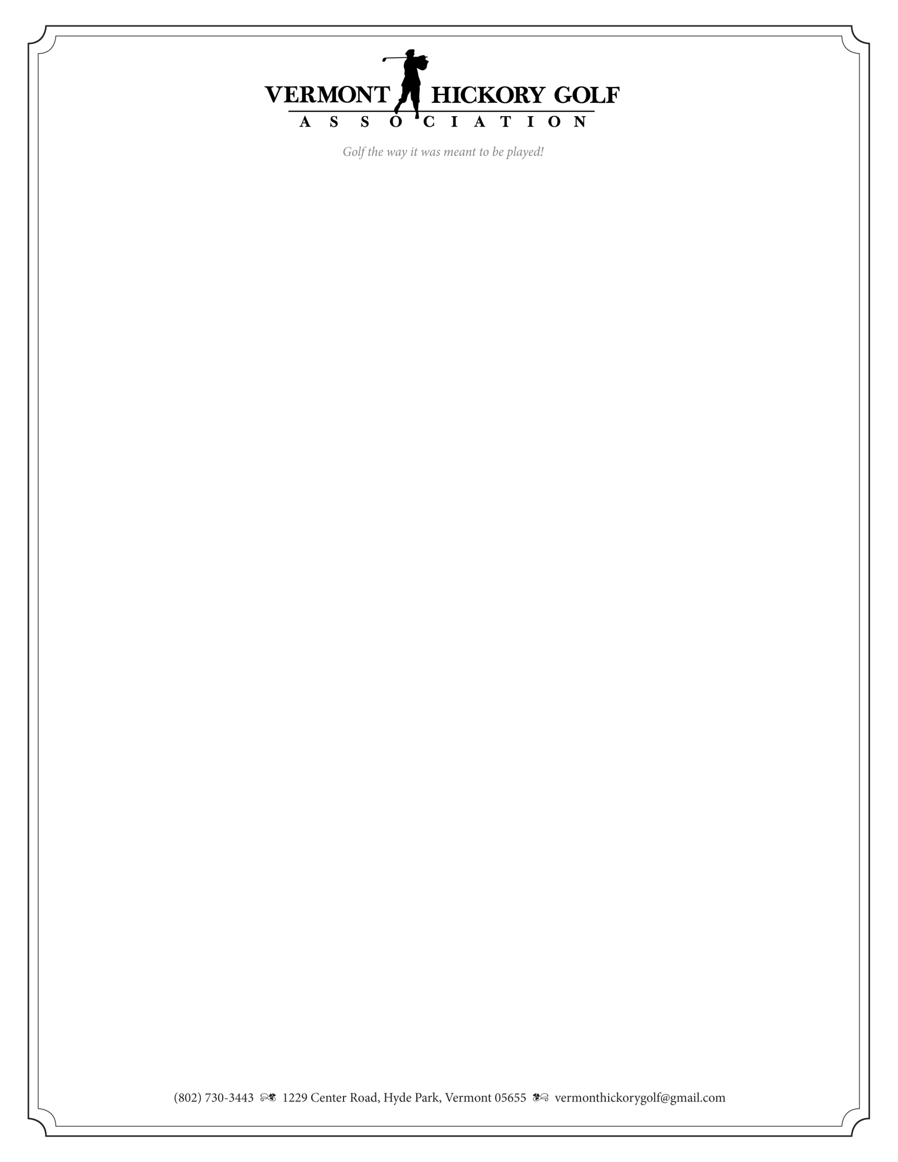

**Notice of Annual Meeting**

**August 8, 2015**

**6:00 PM**

**Williston Golf Club**

**Williston, VT**

**AGENDA**

* Call to Order and Determination of Quorum
* Secretary’s 2014 Annual Meeting Report - Approval

* Treasurer’s Annual Report - Approval

* Nominating Committee Report

Board Members’ Terms Ending 2015:

Patrick Kennedy

Gary Eley

Tom Wawrzeniak

* Unfinished Business
* Other Business
* Adjourn
* Directors meeting to follow immediately after adjournment.