Neshobe Golf Club
yards | 6,349
greens fee | $34-$40
phone | 802/247-3611
location | Brandon, VT
www.neshobe.com

T
he big "moment” at this member-owned course began in 1995 when Vermonter Steve Durkee, at that time an up-and-coming golf architect, overhauled the layout and came up with the 12 new holes. Since this much-needed upgrade, Durkee has designed a new nine at Brattleboro Country Club, a much- celebrated 18 holes at Okemo, and done some preliminary design work at Green Mountain National.
One trip to Neshobe is all one needs to become a fan of Durkee’s talents—particularly when one sees his work juxtaposed against some of the course’s original and still-existing rather vanilla efforts (such as the two opening holes) which Neshobe pro Denis Blanck says will also be replaced when funds are available.
The new holes, most located on the back side of a steep ridge, are clearly the drawing card. With the exception of the par-3 10th, the back nine is pure Durkee, with a fine blend of shotmaking challenges surrounded by picturesque Vermont farmland. You’ll likely have a gallery of Holsteins at the signature 13th hole, a downhill beauty of 387 yards from the back tees. The fairways and greens, particularly on the new holes, are superb, and you’ll cap your round with a memorable tee shot from the elevated, par-4 18th. “The course is aesthetically pleasing and challenging, but it doesn’t beat you up,” says Blanck of the 6,349-yard par-72 layout.
Neshobe is, quite simply, a bustling club. Its 420 members are
based primarily in the Brandon and Rutland areas, as well as Lake Dunmore, Hubbardton and Bom- oseen. But locals don’t have the place all to them themselves. “About 25 percent of our members come from Boston, Connecticut and New York,” Blanck adds.
Perhaps the reason for this out- of-state interest has as much to do with timing as it does the quality of the course: Neshobe has a reputation for being the first course in the state to open (as early as March) and the last to close— sometimes in December.
St. Johnsbury CC
yards | 6,358
greens fee | $30-$35
phone | 802/748-9894
location | St. Johnsbury, VT

T
ucked into a hillside along Route 5, just north of town, St. Johnsbury is a splendid product of Scotland’s Park brothers—Willie Jr. and Mungo—and Geoffrey Cornish, whose stamp is on so many Vermont layouts, notably Killington, Stratton and Quechee’s two 18-hole gems. Willie Park began the nine-
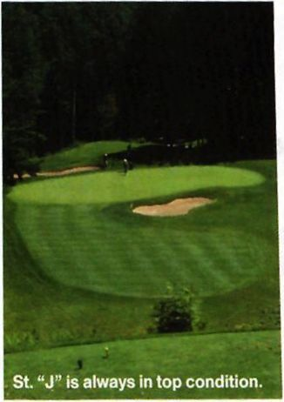

holer before illness forced him to return to Scotland (he died shortly thereafter), and his brother finished the project in 1923.
It was the arrival of Cornish in 1993, however, that catapulted St. Johnsbury into Vermont’s elite group of courses. Handling the elevation changes with typical Cornish dexterity, the back nine is a mixture of visually pleasing and terrifying holes, starting with a blind tee shot to an uphill par five. If a signature hole can be labeled among the sterling homeward nine, it would likely be the 15th, a par-3 that calls for a dramatic downhill tee shot to a narrow but deep green with a hazard to the left. It plays from 122 to 195 yards, depending on the tee box you choose.
"The back nine plays three or four strokes more difficult than the front,” says Steven Holland, the personable pro at the club. “You have to hit it straight; it’s patient golf and target golf. Most people play the whites, even though it’s only 5,853 yards (and par 70).” (The course is 6,358 from the tips.)
With the course earning deserved raves from visitors and its 520 members—most of whom are from St. Johnsbury and nearby towns, such as Danville and Lyndonville—there has been some discussion about a possible renovation project for the aging clubhouse. A new facility wouldn’t be finished by this August’s Vermont Mid-Amateur, which will be hosted here at St. Johnsbury, but could be when the club hosts the 2006 Men’s State Amateur.
Any talk of St. Johnsbury would be incomplete without mentioning the course’s superintendent, Todd Rainville. A legend in Vermont, Rainville is the man to thank for St. Johnsbury’s fairways and greens, which always seem to be in excep tional condition. ■

VERMONT GOLF • 2003
6

