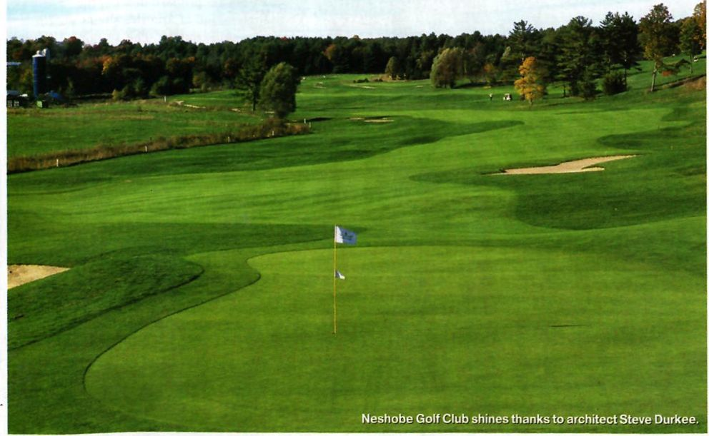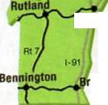

The Price is Right
BY STEVE PIATT
I
Newport.
Burjington _{S}t. Johnsbury CC lee ^SHolmsbury Montpelier
Ueshobe Goll Club
White River Jet.
attleboro
THESE TWO VERMONT LAYOUTS PROVE THAT GREAT GOLF CAN BE EASY ON THE WALLET
64
VKRMONT GOLF • 2003

It would be easy to confuse St. Johnsbury Country Club and Neshobe Golf Club, given their remarkable similarities. For starters, each has a mix of old and new holes, having been boosted from 9 to 18 holes—St. “J” near the northern Vermont town
of the same name, in 1993, and Neshobe, located in Brandon, in 1997. Both layouts have solid membership bases, but see plenty of daily-fee play, both have hosted numerous Vermont Golf Association events, both have a friendly atmosphere, and both boast scenic routings that offer splendid views of Vermont’s farm country (at Neshobe) and mountains (at St. Johnsbury). But perhaps best of all, both courses are among the best golf values in the state, providing a country club experience at bargain prices.

