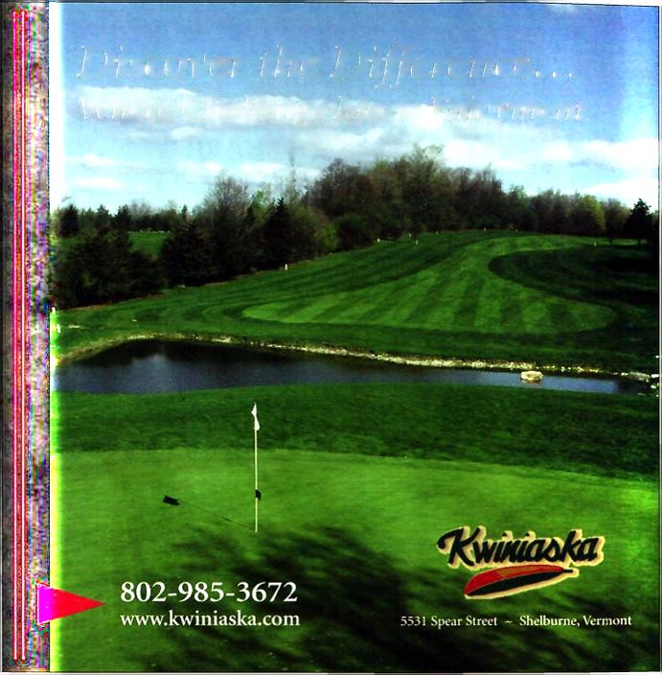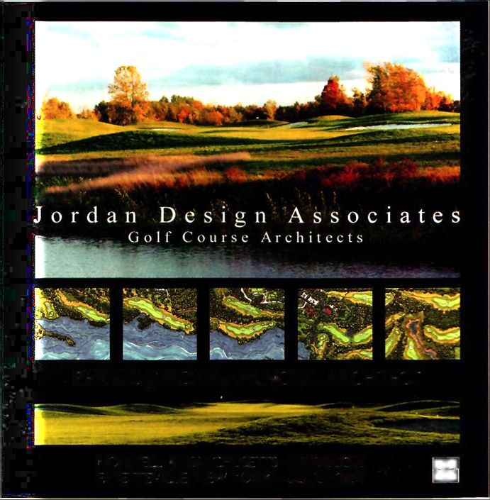
Nothing in Vermont is that precious. Ralph Myhre will force you to play all the shots in your bag. but it never pretends to be all about the golf. Golf here is simply an adjunct to the surroundings—crisp fall, when these green hills transform into confetti and shout at leaf peepers from other continents; spring mud season, when boots are required on elevated tees and casual water blankets the entire course; even winter, when the course’s natural contours transform into death- defying sledding hills. Middlebury students, who also double as hikers, mountain bikers, snow shoers and golfers, all feel they have equal rights to the Ralph Myhre stomping ground. And they do. They don’t call the college “Club Midd” for nothing. Here, recreation rules the day.
When golfers do have full run of the 6,379-yard design, they will find a course low on theatrics and high on beauty. Elevated tee boxes offer inspiring views—Green Mountains to the east and the Adirondacs to the west. Water and sand are used sparingly, as the natural contours of the land add enough bumps and rolls to keep things interesting. Ralph Myhre’s raised greens on the 2nd and 18th holes require heroic approaches when that fierce Canadian wind blows in, and since the greens are the size of cow patties, accuracy, rather than brute strength, is rewarded throughout. Maybe Hall-of-Famer Patty Sheehan learned her attack-the-pin strategy from trying to hit these miniscule greens during her early years here.
Ralph Myhre Golf Course is never going to make it on any “America’s Best” list—and future Charles Howells probably won’t put Middlebury on the list of schools they want to attend—but if you play this course once, you will certainly be back to play it again. ■

Discover the Difference...

Where Challenge Meets Enjoyment.
BARRY L. JORDAN ~ PRINCIPAL ARCHITECT
Amy DiAdamo is a Middlebury grad and Vermont Golf contributing editor.
NORWl LI, MASS At 11US1 I Is - 781.659.3309 I AY 11 II VII l.l , NEW YORK • '315.637.2459

nn

□□

