Find Precious Metals
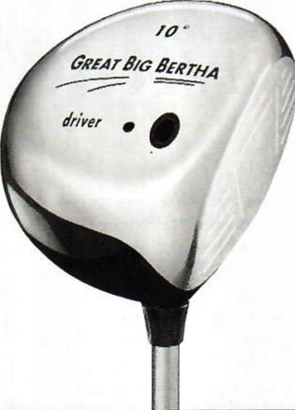
Route 33 Greenland, NH 603-433-8585 Route 12A West Lebanon, NH 603-298-8282 Route 3A Hudson, NH 603-595-8484 www.golfskiwarehouse.com
C^O/va Ion
Pools & Spa”
(802) 893-8900
Toll-Free 1-866-839-8900
Real Service.
Real Experience.
Come see os for oil your pool &spa needs.
Consumer Digest's
Best Buy Winner
2002 & 2003
Premium Spa
Category
Lowest Prices
Highest Quality
Sales & Service
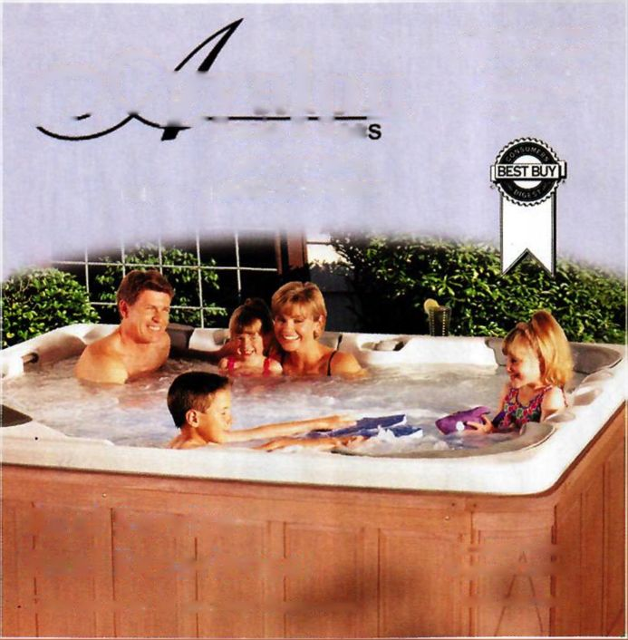Choose from the Tri-State's largest golf inventory and enjoy everyday low prices on quality name brands. Try new clubs on our outdoor ranges. We accept trade-ins, specialize in expert custom fitting, and offer full service repair and club customization. You'll find everything you need to enjoy a great season of golf right here, so swing by today or shop with us online

G*#LF

&sk!
er and local old-timer than the single-digit phenomenon.
Middlebury has never pretended to be true golf country. Its course is well kept, but certainly not pristinely manicured. The range, which doubles as the college’s athletic fields, may be open, or may not. There may be someone in the snack shop to serve you, it may be empty. But for a school that has seen tuition rise to (gasp!) $35,900, good ol’ Ralph Myhre still only charges students $15 for 18 holes ($35 for "outsiders”). In other words, the school encourages students to play whenever the ground has thawed; it even offers golf as a gym credit. So this may not be true golf country in the traditional sense, but that is half of the course’s charm.
The Ralph Myhre Golf Course has none of golfs customary trappings. It is not the work of some storied designer. Unlike the college, it is not demanding, but like everything else in this relaxed valley, it is comfortable and welcoming. The course was originally built as a nine-holer in the 1930s. It was neglected during World War II, and it wasn’t until the late 1940s that the college ponied up the funds to buy the farmland adjacent to the athletic fields needed to expand the course to 18 holes. Still, nothing happened until Ralph Myhre, who ran the course, entered the scene to manage the school’s other “toy," the Snow Bowl (Middlebury’s ski area). Myhre poked and prodded the administration for years, and finally in 1978 the second nine opened. Today, the course is a veritable playground for students looking to take a break from the books, parents who would rather break out the sticks than take little Johnny out to lunch, and alumni who are looking for any excuse to get back to the area.
The round begins and golfers are greeted by expansive fairways bordered by thick, northern rough and pine trees neatly—but certainly not deliberately—lined in single file.
78

