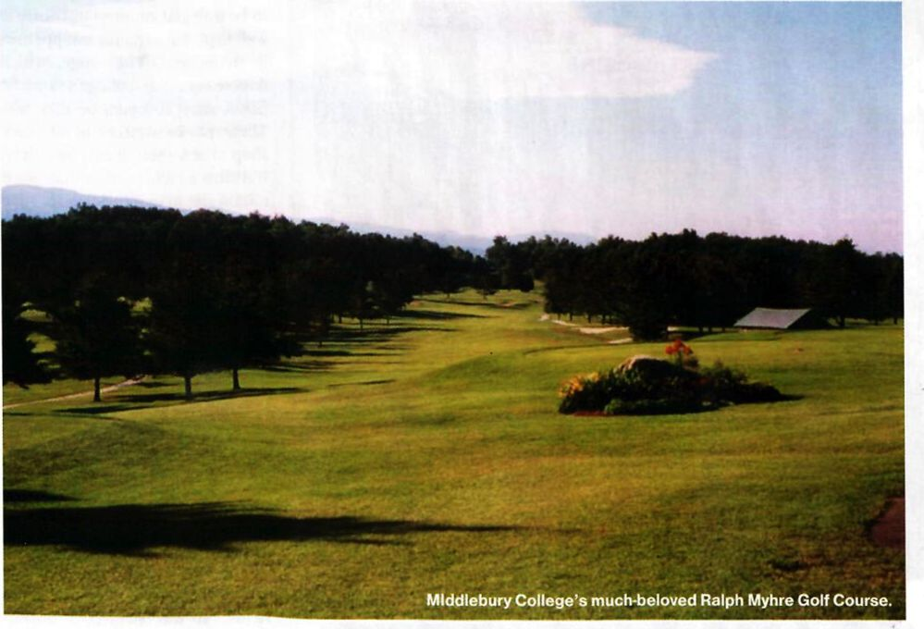College Course

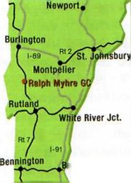Very Merry at Middlebury
rattleboro
THE GOLF COURSE AT THIS FINE COLLEGE WON’T WIN AWARDS— BUT IT WILL WIN YOUR HEART

BY AMY DiADAMO'
While some college golf courses are considered private bastions for golf-scholarship PGA Tour wannabes, Middlebury College’s Ralph Myhre Golf Course is about the average Joe and Jane getting out on the links and burning off some classroom stress. Though Middlebury has had some diamonds in the rough—LPGA Tour Hall- of-Famer Patty Sheehan, bom and raised in Middlebury, Vermont; and the 2002 golf team, which posted the school’s best season by winning the New England Small College Athletic Conference (NESCAC)
Ralph Myhre GC
yards | 6,379
greens fee | $15-$35
phone | 802/443-5125
location | Middlebury, VT

Championship—the course here has always been more about the student hack-
VERMONT GOLF . 2003
77

