For the Good of the Game

Few people have given as much to women’s
golf in Vermont as Margaret Dick
By Arthur Ristau

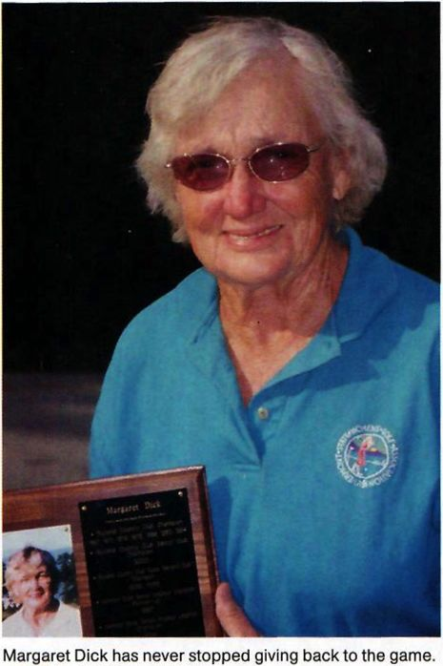
If there was an award for the First Lady of Vermont Golf, it would be hard to argue against giving that honor to Margaret Dick. From competing to teaching to cochairing the Rating Committee of the Vermont State Women’s Golf Association (VSWGA), this classy 77-year-old Rutland widow lends new context to that venerable saw about 'giving back.”
“She’s extremely unselfish about giving her time to golf,” asserts Cathy Brown of Brandon, President of the VSWGA. She’s a very positive and enthusiastic role model for all of us.”
Margaret Dick and the iconic Mae Murray Jones, the finest amateur golfer in Vermont’s history, are the sole surviving female members of the Rutland Country Club’s Hall of Fame. Jones, now in her seventies, lives in a retirement home in Lancaster, Pennsylvania, and hasn’t played for many years. Her father, the late Jim Murray, was the first pro Margaret studied with; this was back in 1955 when Margaret joined the Rutland Country Club. Margaret Dick proved an apt pupil winning the club championship seven times over four decades, with a last triumph coming in 1994 at age 68. She was state Legends champion in 1998.
When the Rating Committee of the VSWGA was created 20 years ago, Margaret Dick was one of its original members. Barre residents Jo Anne Richardson, who was on the initial team, and Marilyn Patton, Dick’s co-chair who joined after Dick and Richardson, are still active in
the organization.
“In the beginning,” Dick recollects, “we were very busy. Now, we routinely schedule between five and nine courses a year unless there has been a substantial change in a course design or layout. We try to rate each course at least every ten years.”
Slope standards originated in the dreary, doorstop- size USGA Course Rating System Manual 6[ Guide. Slope assessment techniques were approved as a refinement of the Association’s handicap system, designed to rate courses for a range of abilities, thereby creating a technique to adjust a golfer’s handicap to the difficulties of the course being played and rendering one’s handicap “portable.”
“We consider 10 factors on each hole,” says Dick about the rating process,” and distance is the most significant. “A scratch golfer,” she amplifies, “hits her tee shot an average of 210 yards and a bogey golfer perhaps about 150 yards. Then we evaluate landing zone characteristics, such as fairway width and pitch, bunker proximity, the angle of a typical lie, water and the distance to the green and its depth. Two imaginary golfers, "Scratch” and “Bogey” are visualized as rating prototypes and the system reflects the presumed skills of each. Numbers are assigned to each shot and their accumulation, paired with a multiplier, yields the slope.
“My course (Rutland) is a good example,” Dick points out. “It’s much more difficult for women who shoot bogey than for men who shoot bogey, so the (women’s) slope is

VERMONT GOLF • 2003
41

